**Base Query 1**

SELECT L.Location_Id,L.Location_Name,

S.Sales_Class_Id,S.Sales_Class_Desc,S.Base_Price,

T.Time_Year,T.Time_Month,

SUM(A.Quantity_Ordered) AS TotalJobQuantity,

SUM(A.Quantity_Ordered*Unit_Price) AS TotalJobAmount

FROM W_Job_F A,

W_Location_D L,

W_Time_D T,

W_Sales_Class_D S

WHERE L.Location_ID = A.Location_Id

AND A.Contract_Date = T.Time_Id

AND A.Sales_Class_Id = S.Sales_Class_Id

GROUP BY L.Location_Id,L.Location_Name,

S.Sales_Class_Id,S.Sales_Class_Desc,S.Base_Price,

T.Time_Year, T.Time_Month;

**Snapshot**

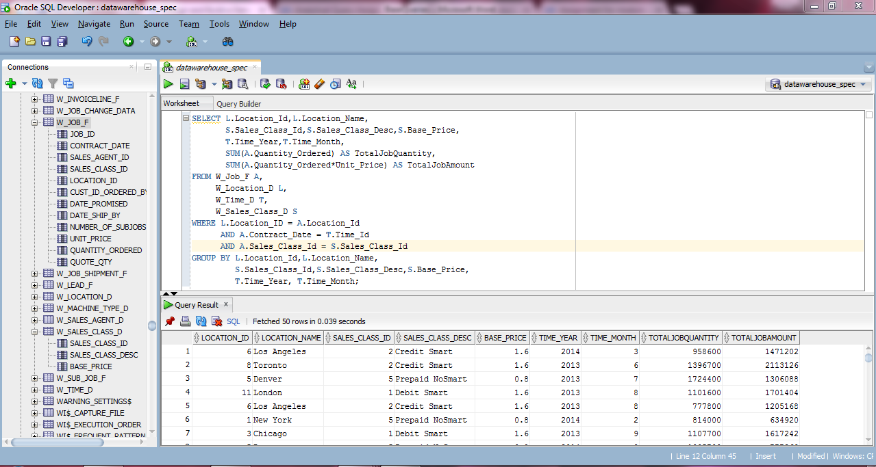

**Base Query 2**

CREATE VIEW LocationInvoiceRevenueSummary AS

SELECT S.Job_Id,

L.Location_Id,L.Location_Name,

O.Quantity_Ordered,O.Unit_Price,

T.Time_Year,T.Time_Month,

SUM (I.Invoice_Quantity) TotalInvoiceQuantity,

SUM (I.Invoice_Amount) TotalInvoiceAmount

FROM W_Job_Shipment_F J,

W_Sub_Job_F S,

W_Location_D L,

W_Time_D T,

W_InvoiceLine_F I,

W_Job_F O

WHERE S.Sub_Job_Id = J.Sub_Job_Id

AND J.Invoice_Id = I.Invoice_Id

AND T.Time_Id = O.Contract_Date

AND L.Location_Id = I.Location_Id

AND O.Job_Id = S.Job_Id

GROUP BY S.Job_Id,

L.Location_Id,L.Location_Name,

O.Quantity_Ordered,O.Unit_Price,

T.Time_Year,T.Time_Month;

**Snapshot**

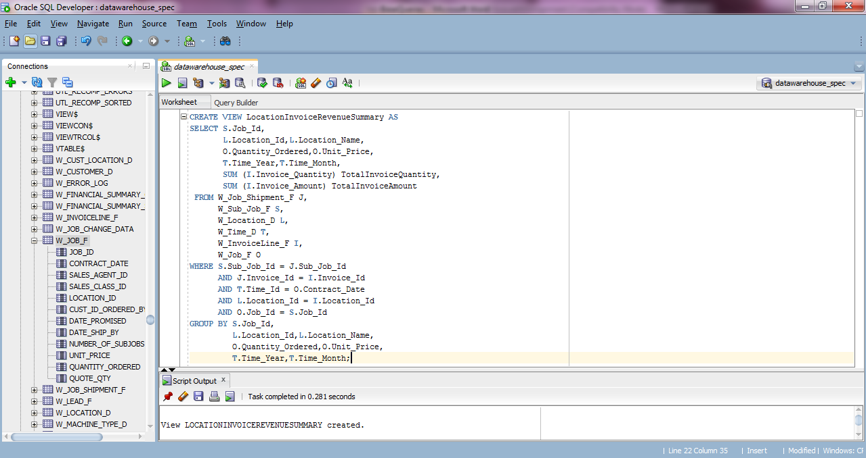

**Base Query 3**

CREATE VIEW LocationSubjobCostSummary AS

SELECT S.Job_Id,

L.Location_Id,L.Location_Name,

T.Time_Year,T.Time_Month,

SUM(S.Cost_Labor) TotalLaborCost,

SUM(S.Cost_Material) TotalMaterialCost,

SUM(S.Cost_Overhead) TotalOverheadCost,

SUM(S.Machine_Hours * M.Rate_Per_Hour) TotalMachineCost,

SUM(S.Quantity_Produced) TotalQuantityProduced,

SUM(Cost_Labor + Cost_Material + Cost_Overhead +

(Machine_Hours * Rate_Per_Hour)) TotalCost,

SUM(Cost_Labor + Cost_Material + Cost_Overhead +

(Machine_Hours * Rate_Per_Hour)) / SUM(Quantity_Produced) UnitCost

FROM W_Job_F O,W_Sub_Job_F S,

W_Location_D L,

W_Time_D T,

W_Machine_Type_D M

WHERE O.Location_Id = L.Location_Id

AND S.Machine_Type_Id = M.Machine_Type_Id

AND T.Time_Id = O.Contract_Date

AND O.Job_Id = S.Job_Id

GROUP BY S.Job_Id,

L.Location_Id,L.Location_Name,

T.Time_Year,T.Time_Month;

**Snapshot**

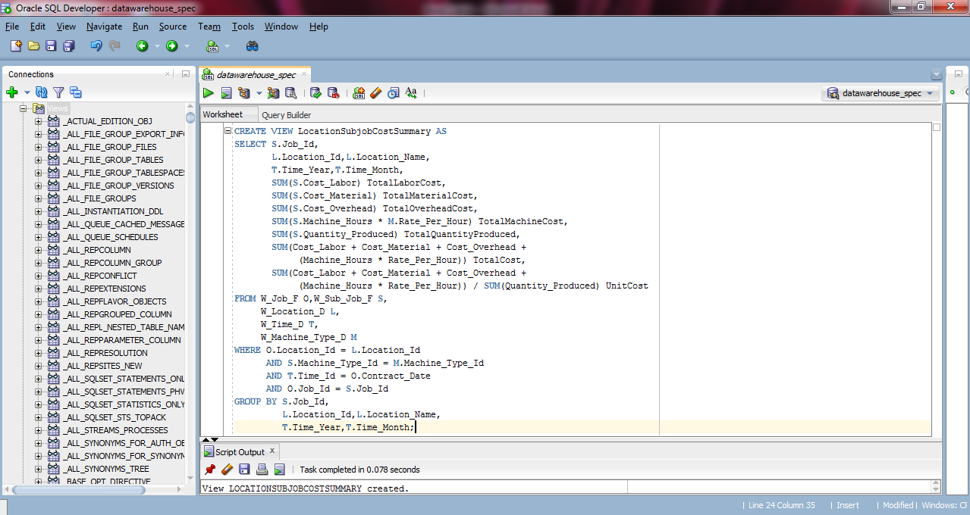

**Base Query 4**

SELECT L.Location_Id,L.Location_Name,

S.Sales_Class_Id,S.Sales_Class_Desc,

T.Time_Year,T.Time_Month,

SUM(I.Quantity_Shipped - I.Invoice_Quantity) TotalReturnQuantity,

SUM( (I.Quantity_Shipped - I.Invoice_Quantity) *

(I.Invoice_Amount / I.Invoice_Quantity) ) TotalReturnAmount

FROM W_InvoiceLine_F I

INNER JOIN W_Time_D T ON I.Invoice_Sent_Date = T.Time_Id

INNER JOIN W_Location_D L ON I.Location_Id = L.Location_Id

INNER JOIN W_Sales_Class_D S ON I.Sales_Class_Id = S.Sales_Class_Id

WHERE I.Quantity_Shipped > I.Invoice_Quantity

GROUP BY L.Location_Id,L.Location_Name,

S.Sales_Class_Id,S.Sales_Class_Desc,

T.Time_Year,T.Time_Month;

**Snapshot**

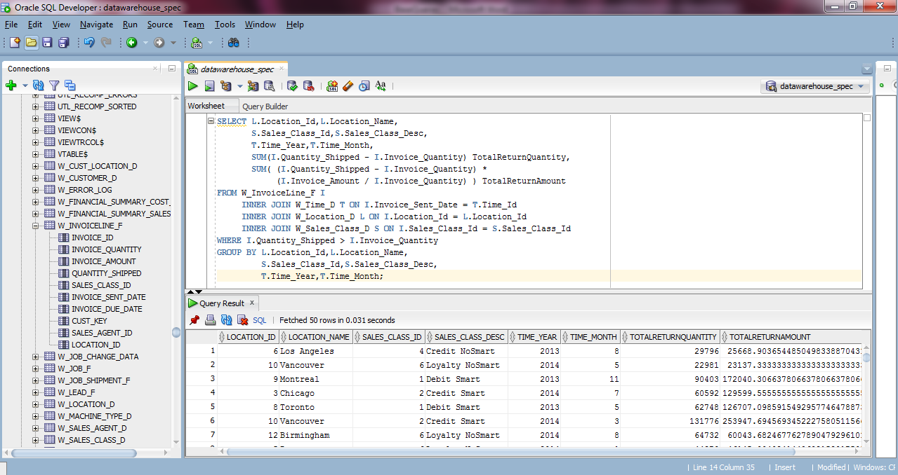

**Base Query 5**

CREATE VIEW LastShipmentDelays AS

SELECT J.Job_Id,

S.Sales_Class_Id,S.Sales_Class_Desc,

L.Location_Id,L.Location_Name,

J.Date_Promised,X1.Last_Shipment_Date,

J.Quantity_Ordered,X1.SumDelayShipQty,

GetBusDaysDiff(J.date_promised,X1.Last_Shipment_Date) BusDaysDiff

FROM W_Job_F J,

W_Location_D L,

W_Sales_Class_D S,

( SELECT W_SUB_JOB_F.JOB_ID,

MAX(actual_ship_Date) AS Last_Shipment_Date,

SUM (actual_quantity) AS SumDelayShipQty

FROM W_JOB_SHIPMENT_F, W_SUB_JOB_F, W_Job_F

WHERE W_SUB_JOB_F.SUB_JOB_ID = W_JOB_SHIPMENT_F.SUB_JOB_ID

AND W_Job_F.Job_Id = W_SUB_JOB_F.JOB_ID

AND Actual_Ship_Date > Date_Promised

GROUP BY W_SUB_JOB_F.JOB_ID

) X1

WHERE J.Date_Promised < X1.Last_Shipment_Date

AND J.Job_Id = X1.Job_Id

AND J.Location_Id = L.Location_Id

AND J.Sales_Class_Id = S.Sales_Class_Id;

**Snapshot**

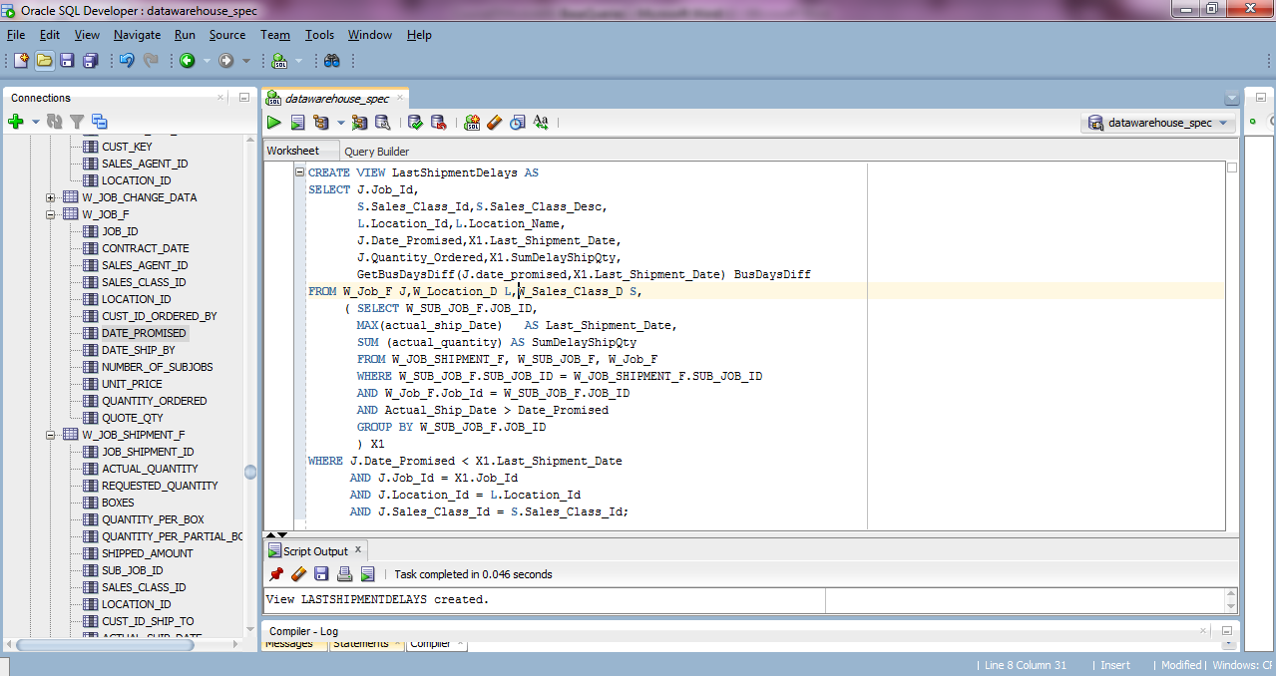

**Base Query 6**

CREATE VIEW FirstShipmentDelays AS

SELECT J.Job_Id,

S.Sales_Class_Id,S.Sales_Class_Desc,

L.Location_Id,L.Location_Name,

J.Date_Ship_By,

X1.FirstShipDate,

GetBusDaysDiff(J.Date_Ship_By,X1.FirstShipDate) BusDaysDiff

FROM W_Job_F J,

W_Location_D L,

W_Sales_Class_D S,

(SELECT W_SUB_JOB_F.JOB_ID, MIN(Actual_Ship_Date) as FirstShipDate

FROM W_JOB_SHIPMENT_F, W_SUB_JOB_F

WHERE W_SUB_JOB_F.SUB_JOB_ID = W_JOB_SHIPMENT_F.SUB_JOB_ID

GROUP BY W_SUB_JOB_F.JOB_ID

) X1

WHERE J.Date_Ship_By < X1.FirstShipDate

AND J.Job_Id = X1.Job_Id

AND J.Location_Id = L.Location_Id

AND J.Sales_Class_Id = S.Sales_Class_Id;

**Snapshot**

